GUIDELINES FOR RENEWING MEMBERSHIPS/NEW MEMBERS

RENEWING MEMBERSHIPS:

If a renewing member has any questions regarding renewing their membership, please be advised that there is a demo video on the login screen (see below). Please be advised that ALL Active, Returning, Renewing NHSRA members ALREADY have an account
setup. PLEASE ADVISE YOUR MEMBERS NOT TO CREATE A NEW ACCOUNT.
[See below for reference on the login screen]

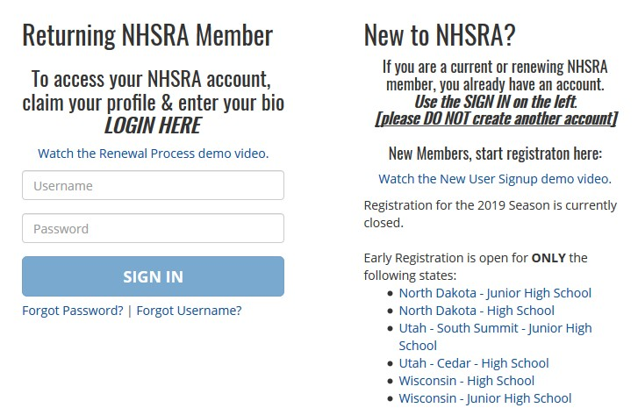

If a renewing member, District Secretary and/or State Secretary creates a new account for an existing member, it will be deleted and the member will have to go into their existing account to complete their registration. In addition, any documents uploaded into the new account will have to be uploaded into the existing account by the member.

As secretaries, you have access to all your members’ profiles, which contains their usernames and email addresses.

Below are instructions on how members access their profiles, see below:

- If a member does not know their username, they can click “Forgot Username?” to receive an email providing this information or they can contact you to obtain their username.

- If a member does not know their password, they can click “Forgot Password?” to receive an email with a link to reset their password.

- Please be advised that if a member clicks “Forgot Username?” and/or “Forgot Password?” and does not receive an email, it is probably because the email address on their profile is not current. If this is the case, you will have to edit their profile to correct their email address in order for them to receive the email with their username and/or password reset link.

If you or the member cannot find their existing profile, their status may be inactive or deleted. Our office will have to restore their profile before you or the member are able to access it. If you are unable to locate their existing profile, please call Cindy at 303-452-0820 or email her at membership@nhsra.org.

NEW MEMBERS:

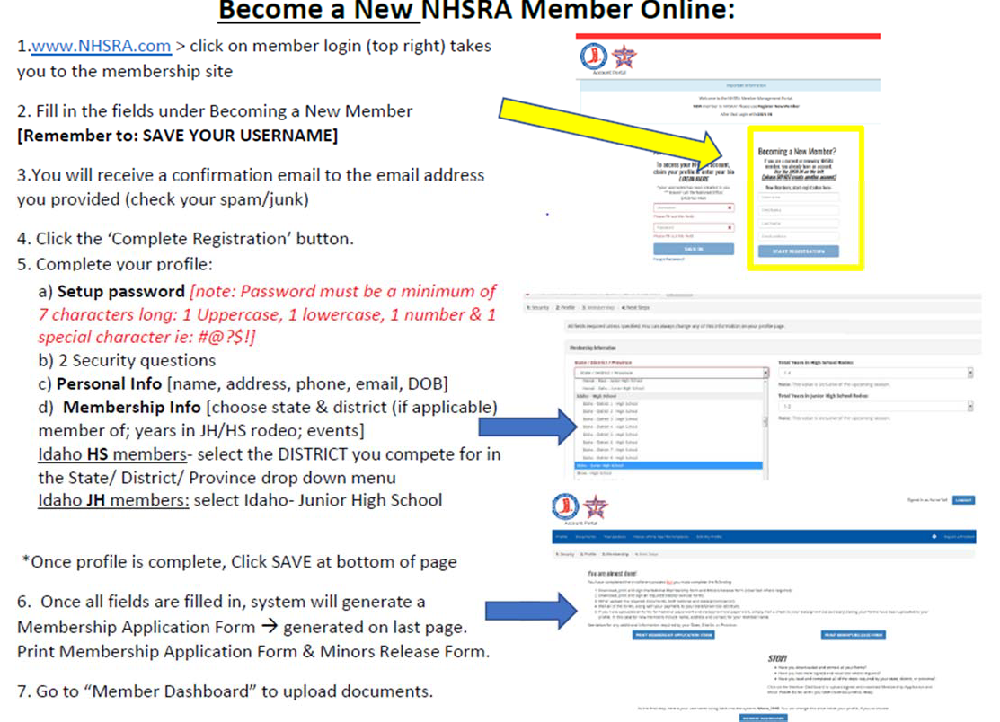
If a new member has any questions regarding creating their membership, please be advised that there is a demo video on the login screen (see below).

