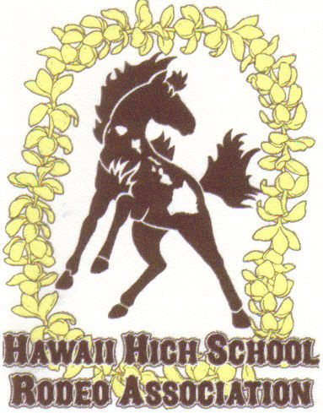
SOCIAL MEDIA POLICY

In accordance with 2020 – 2022 Rules, By-laws and Constitution, National High School Rodeo Association, Article II: Membership Associations - Membership, 16. “NHSRA membership associations shall have the authority to require signature agreements to Social Media Policies for student and adult members, as a requirement of membership. The purpose of said policies is to protect the membership association and its official representatives from inaccurate, detrimental, threatening, harassing and derogatory information, as well as from creating unauthorized websites and social media accounts utilizing the association name, whether directly or indirectly.”
As a condition of membership in HHSRA (the “Hawai`i High School Rodeo Association”), the undersigned understand that the Hawai`i High School Rodeo Association requires student, parent and adult non-parent members to agree not to post on line any comments about the National High School Rodeo Association, the Hawai`i High School Rodeo Association, and/or its official representatives that are inaccurate, detrimental, threatening, harassing and/or derogatory, as well as to agree not to create unauthorized websites and social media accounts utilizing the Hawai`i High School Rodeo Association name, whether directly or indirectly.

We further understand that failure to abide by this agreement by either adult members, parent(s) or student member(s) will result in immediate revocation of all the undersigned’s adult and student memberships in the Hawai`i High School Rodeo Association, including any points awarded in the current 2021-2022 rodeo season. This revocation of membership shall not, however, preclude the Hawai`i High School Rodeo Association from bringing a claim against an adult member, parent or a parent on behalf of their minor child(ren) who is a member(s), for appropriate damages caused by the actions of either the parent, adult non-parent or student. By signing below, the undersigned agree to this Social Media Policy.

_____________________________________ Hawai`i High School Rodeo Association Student Member), _____________________________________ (Hawai`i High School Rodeo Association Adult Board Member), _____________________________________ (Hawai`i High School Rodeo Association Parent), _____________________________________ (Hawai`i High School Rodeo Association Parent).

The foregoing Social Media Policy agreement is hereby accepted:

Hawai`I High School Rodeo Association

By:___________________________________

